## Lab Objective and Due Date:

Understand and implement cloud security governance best practices in an AWS environment. This lab assignment is due on **February 19, 2024.**

## Pre-Lab Setup:

1. AWS Account Setup
2. [Resource Allocation](https://aws.amazon.com/getting-started/hands-on/control-your-costs-free-tier-budgets/): Assign budget limits and monitor usage to prevent unexpected costs.

## Lab Exercise:

### Part 1: Understanding AWS Security and Compliance

1. Enable AWS Security Hub. **Provide a screenshot of Security Hub active in your environment.**

1. Create an AWS Service Control Policy that only allows users to create EC2 instances and S3 buckets in the US East 1 region.

1. Create a user that is able to set up EC2 instances. Log in as that user and create an EC2 instance. Provide a screenshot of **the user you created** and **the EC2 instance you created.**

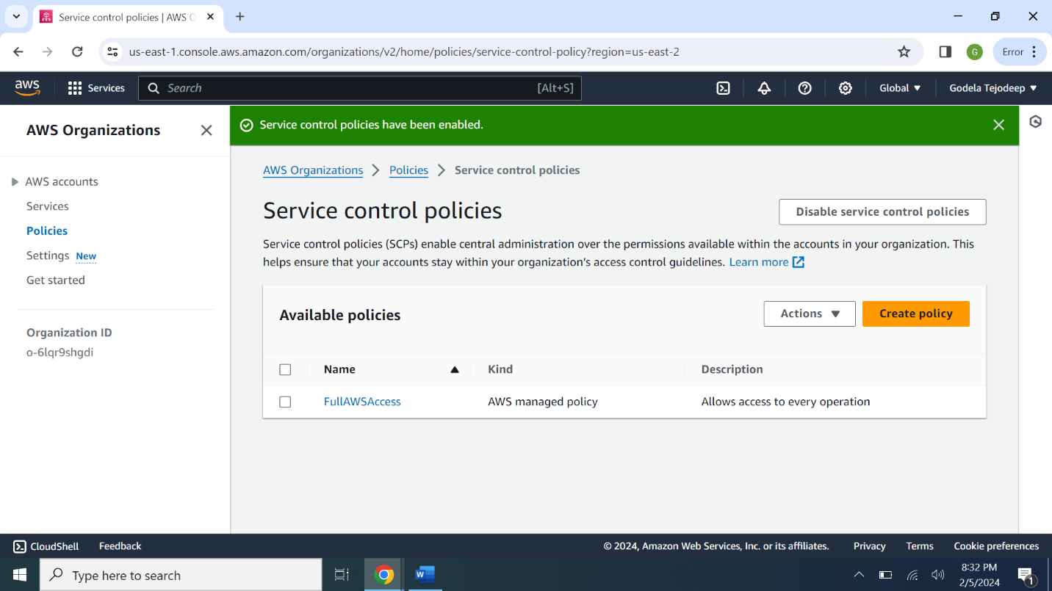

1. Using that same user, switch to any region other than US East 1 and try to create an EC2 instance. **Provide a screenshot of the error you receive when you do this.**

1. Review AWS Artifact. **Provide a screenshot of the AWS Artifact interface.**

**Contd……..**

### Questions to Answer:

1. What is the benefit of AWS Security Hub? Why should companies enable this service?

**Answer:** Security standards enables the user to track your cloud security posture with a summary security score and standard security scores

In this lab we enforced 2 security standards namely

* **AWS Foundational Security Best Practices v1.0.0**
* **CIS AWS Foundations Benchmark v1.2.0**

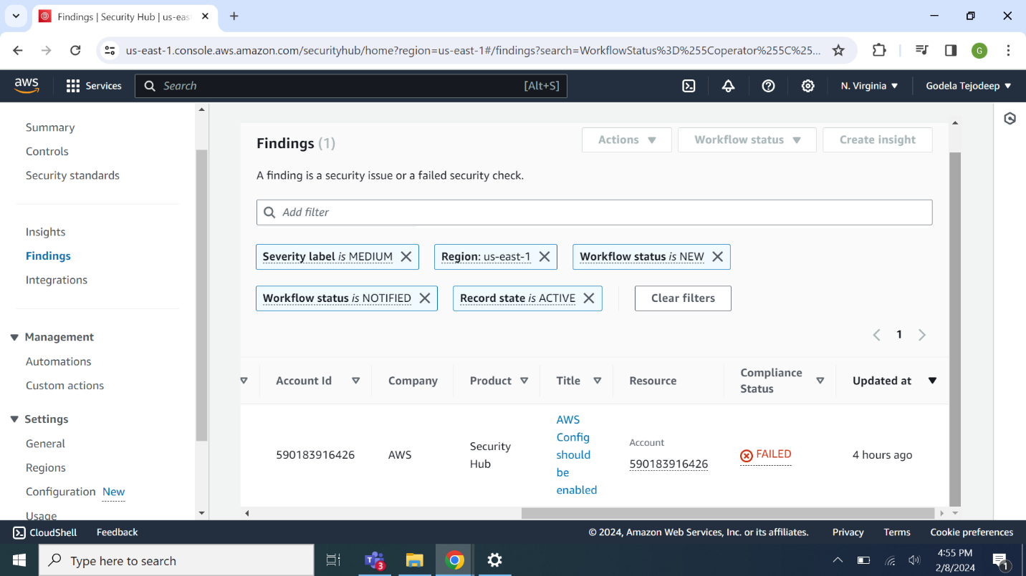

In the above screenshot as I entered password incorrect you can see in compliance status and considered critical

1. What is the benefit of AWS Service Control Policies? How do they help companies manage governance and compliance?

**Answer:** AWS Organizations is a service for grouping and centrally managing multiple AWS accounts. A service control policy (SCP) limits permissions for entities in member accounts in AWS Organizations.

Basically creating a dashboard of services to the user working on a particular region enabling us to implement LPP[Least Privilege Policy] Access management. So the user can login from any part of the globe he can work on those services explicitly in that region like EC2 Instances,S3 Buckets

1. Why do companies use AWS Artifact?

**Answer:** Reports are documents that AWS has made available on-demand to the customers. Some reports are available to all customers while others are available only to select customers depending on need-to-know basis.

<https://docs.aws.amazon.com/artifact/latest/ug/what-is-aws-artifact.html>

An example like You can also use AWS Artifact to review, accept, and track the status of AWS agreements such as the Business Associate Addendum (BAA). A BAA typically is required for companies that are subject to the Health Insurance Portability and Accountability Act (HIPAA) to ensure that protected health information (PHI) is appropriately safeguarded.